Merge Sort Output

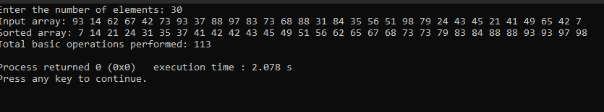

Merge Sort efficiency

|  |  |  |  |
| --- | --- | --- | --- |
| N | Count/n | Count/n^2 | Count/nlogn |
| 10 | 1.9 | 0.19 | 1.9 |
| 100 | 5.37 | 0.0537 | 2.685 |
| 150 | 6.06 | 0.0404 | 13.1871 |
| 200 | 6.285 | 0.031425 | 2.731385515 |